# INTRODUCTION

Configure the Oracle Clusterware and RAC 10g software on Sun SPARC M4000.

# Database information

## Database – RAC

| Serial No | ITEMS | Values |
| --- | --- | --- |
| 1 | Oracle SID  Service_name |  |
| 2 | Oracle Home Directory | /u01/app/oracle//10.2.0/db |
| 3 | CRS Home Directory | /u01/app/oracle//10.2.0/crs |
| 4 | Location of pfile | Storages disk |
| 5 | Location of alert log | Local disk |
| 6 | Virtual IP Address and netmask of this instance |  |
| 7 | Oracle RDBMS Software installed (Version, Enterprise/Standard) | 10.2.0.1 |
| 8 | Oracle database files are managed by | ASM |
| 9 | Database 10g Patch version | 10.2.0.4 |
| 10 | Oracle base dir | /u01/app/oracle |
| 11 | Check Character set | **UTF8** |
| 12 | Process | **2048** |
| 13 | Memory | **65% total Physical memory** |

## Listener Information

| Serial No | ITEMS | Values |
| --- | --- | --- |
| 1 | LISTENER name listed in the tnsnames.ora file. E.g. listener | LISTENER |
| 2 | Home | Local Disk |
| 3 | TnsAdmin | Local Disk |
| 4 | Virtual IP Address and netmask of this listener |  |
| 5 | Listener port number. E.g. 1521 | 1521 (default) |

# INSTALLING ORACLE CLUSTERWARE

## Verify Oracle Clusterware Requirements with CVU

Using the following command to verify and check system requirements before starting to install Oracle Clusterware.

$/*mountpoint*/runcluvfy.sh stage -pre crsinst -n *node_list*

The Cluster Verification Utility Oracle Clusterware preinstallation stage check verifies the following:

* Node Reach ability:
* User Equivalence:
* Node Connectivity:
* Administrative Privileges:
* Shared Storage Accessibility:
* System requirements:
* Kernel Packages:
* Node Applications:

## Preparing to install Oracle CRS with OUI

* Shutdown all running Oracle Processes
* Determine the Oracle Inventory Location (oraInventory)

|  |  |
| --- | --- |
| Oracle Inventory Location | /oracle |

* Obtain root account access
* Determine cluster name, public node names, private node names, and virtual node names for each node in the cluster.

## Confirming Oracle Clusterware Funtion

After installation, log in as root, and use the following command syntax to confirm that your Oracle Clusterware installation is installed and running correctly

#CRS_HOME/bin/crs_stat –t

## Oracle Clusterware Postinstallation Procedures

### Required Postinstallation Tasks

1. Backup the voting disk after installation

***Using cp command to backup the Voting disk***

Perform this task after you complete any installation, node addition, and node deletions.

1. Download and Install Patch updates

List of Patches to apply:

* Patchset 3 (10.2.0.4)

### Recommended Postinstallation Tasks

Oracle recommends that you backup root.sh script after you complete an installation.

# Installation screen shot

## CRS Installation screen shot

* Begin Installation:

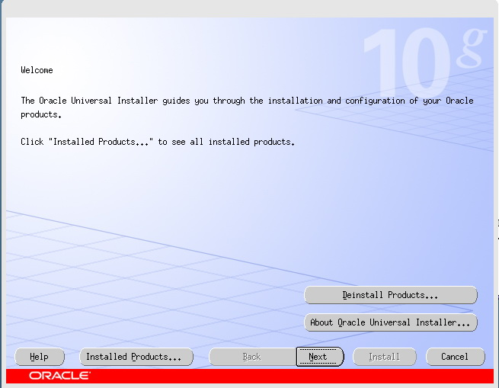

* Specify Inventory directory and credentials:

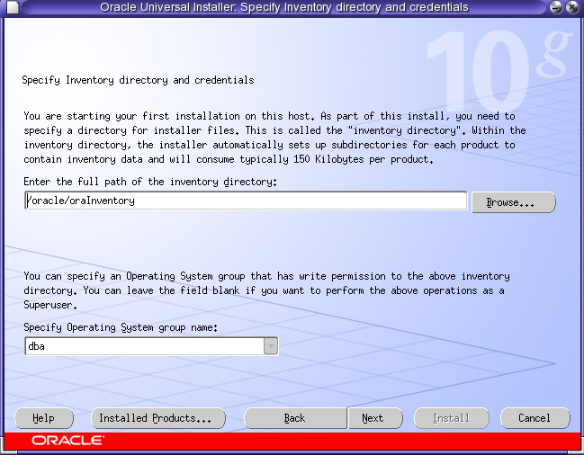

* Specify Home Details:

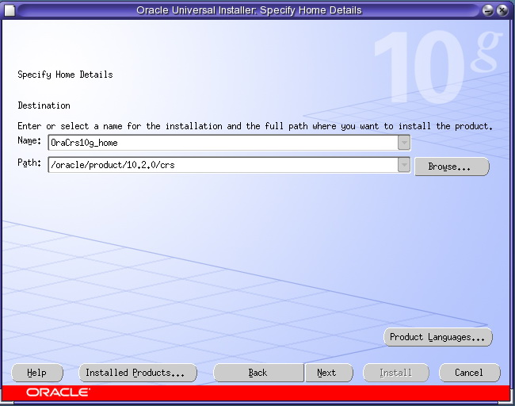

* Specify Cluster Configuration:

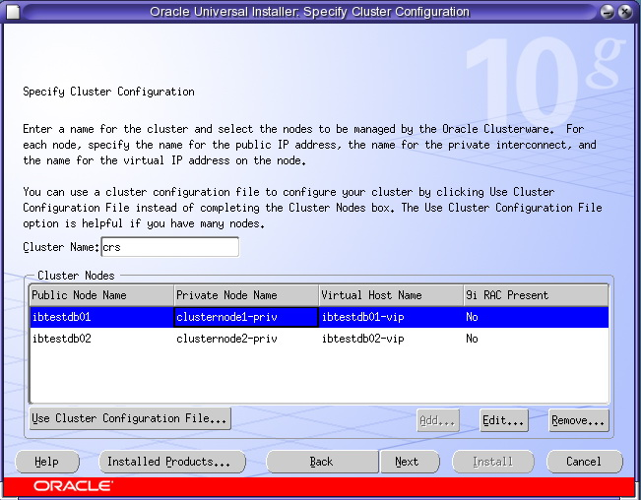

* Specify Network Interface Usage:

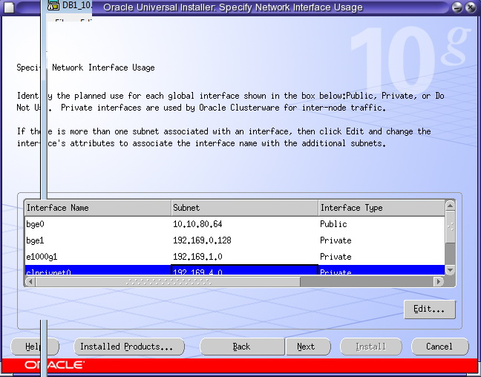

* Specify Oracle Cluster Registry (OCR) Location:

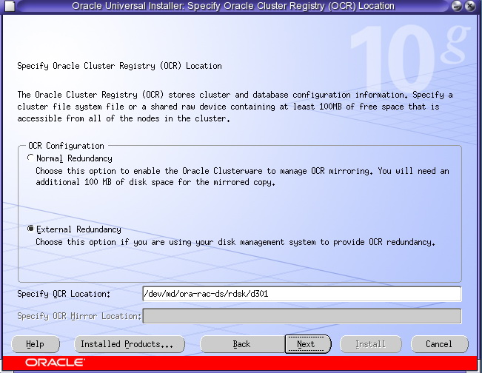

* Specify Voting Disk Location:

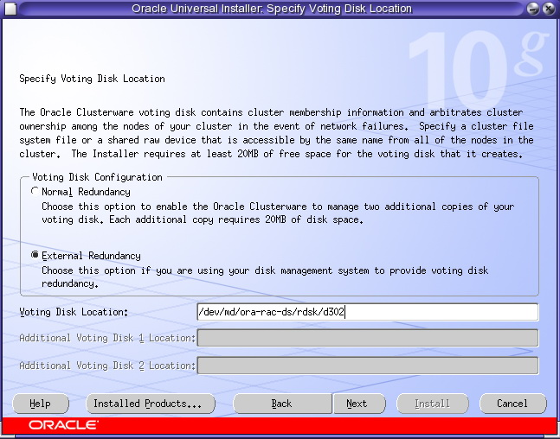

* Installation progress:

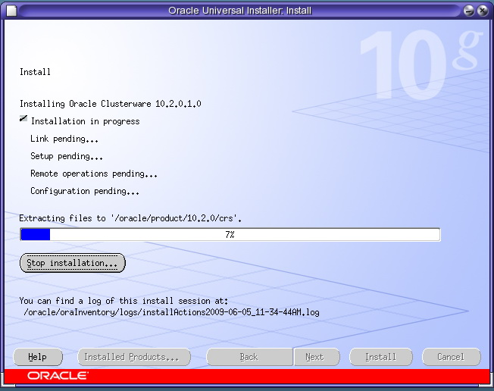

* Upgrade CRS:

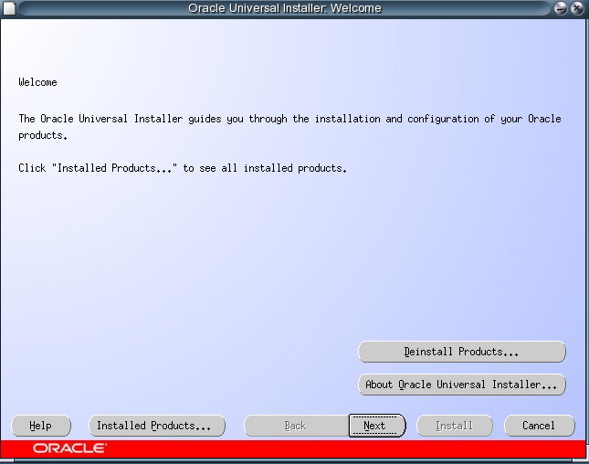

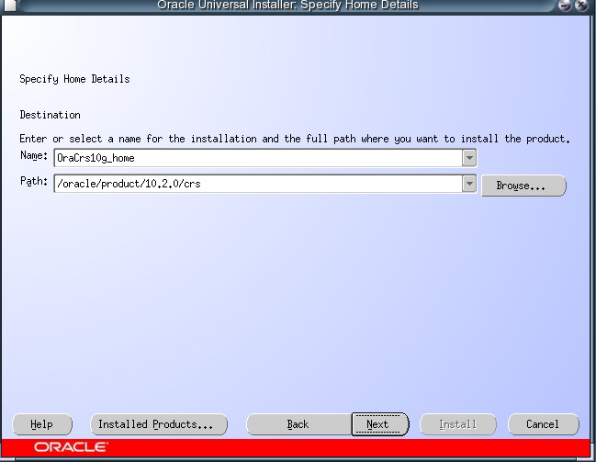

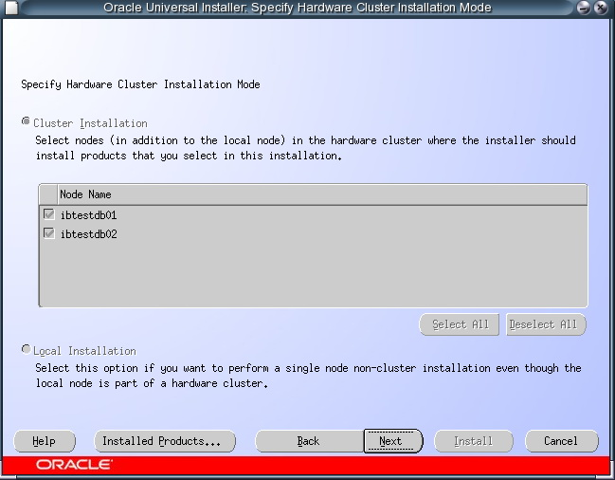

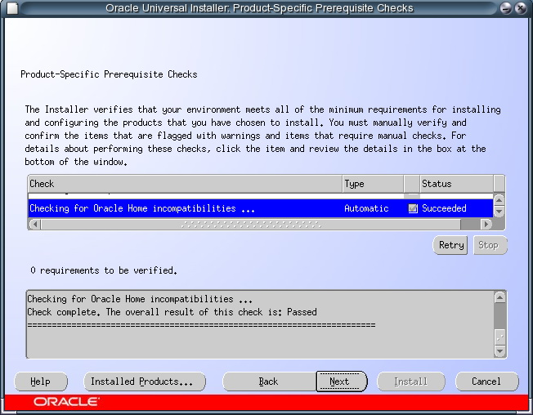



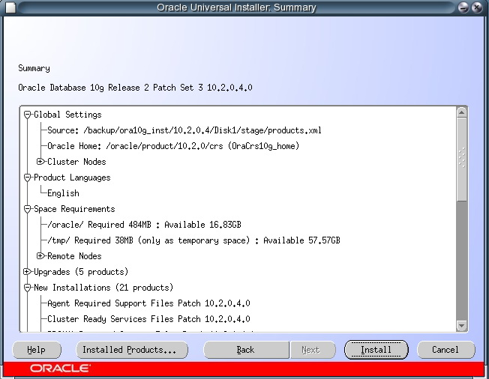

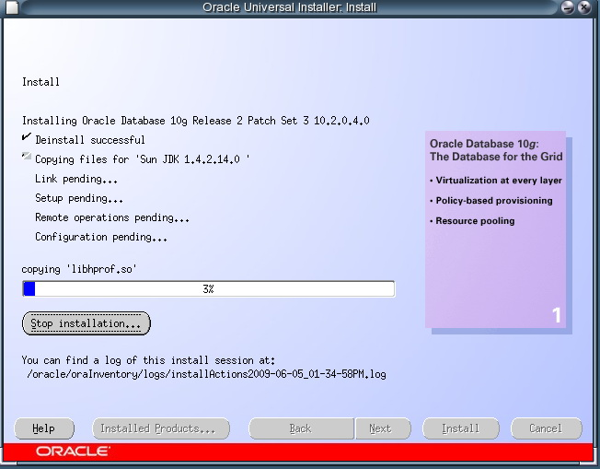

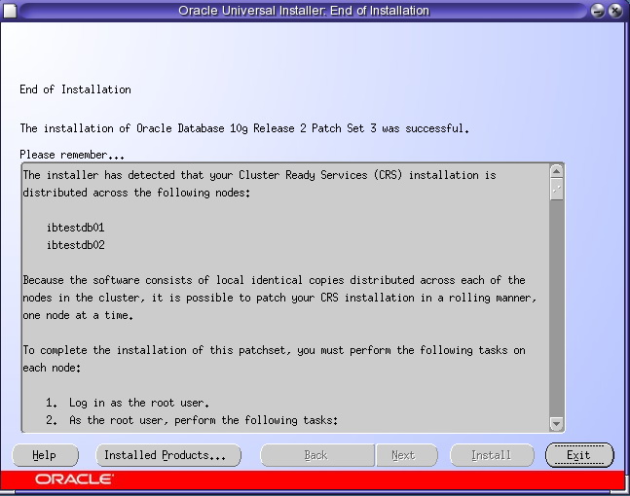

## Oracle Software installation screen shot

### Install Database Software:

* Select Installation Type:

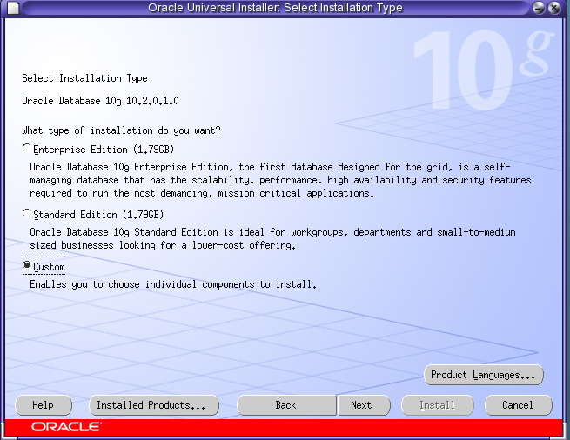

* Specify Home Details

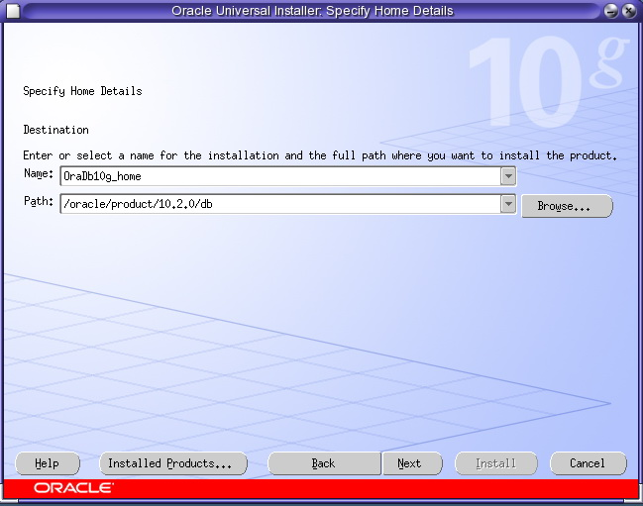

* Specify Hardware Cluster Installation Mode:

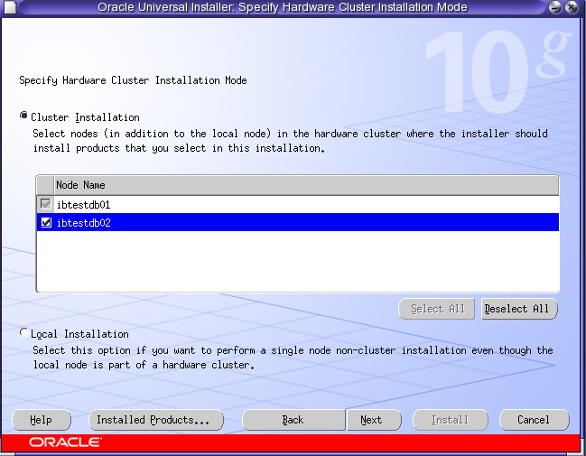

* Product – Specific Prerequisite Checks

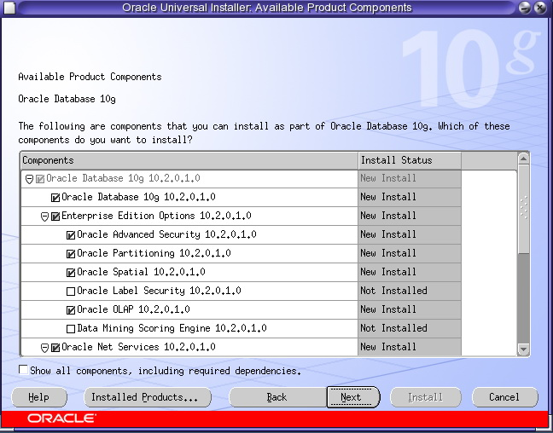

* Select Configuration Options:

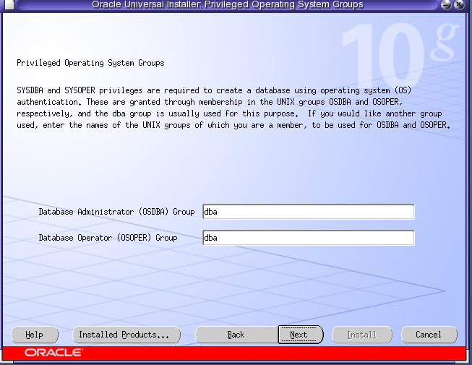

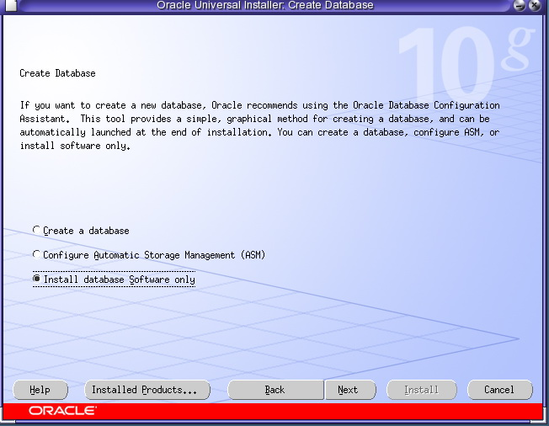

* Install progress

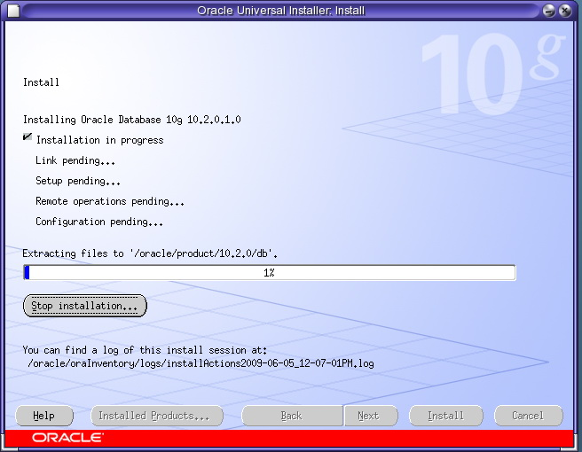

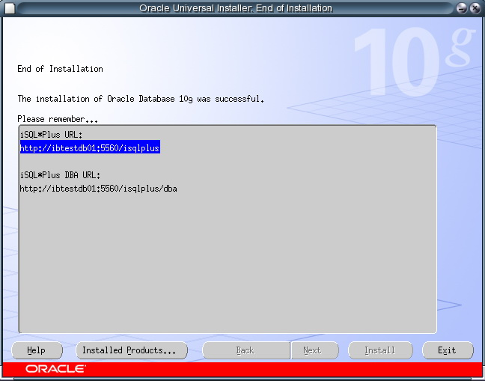

### Create Database

* Database Configuration Assistant : Node Selections

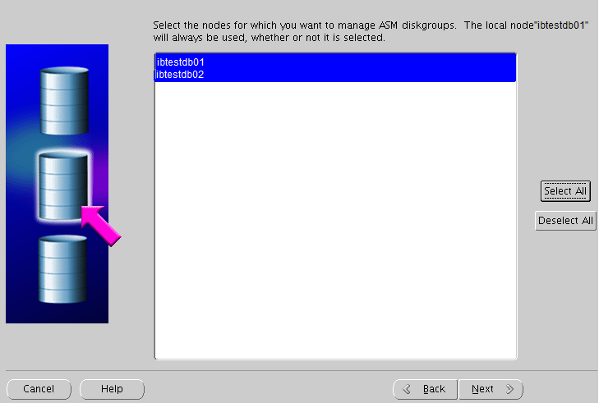

* Create ASM Instance

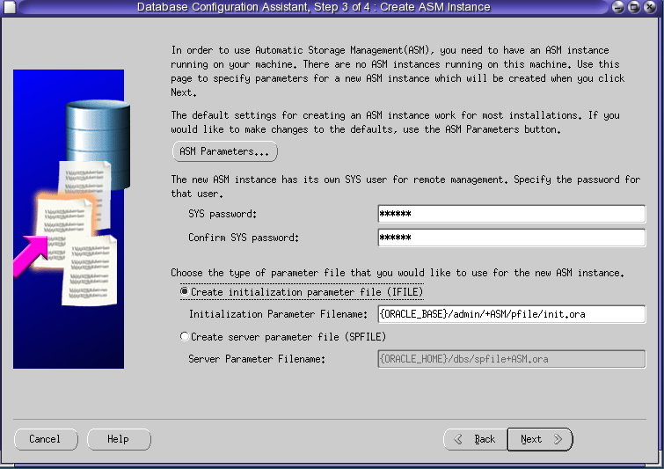

* ASM Disk Groups:

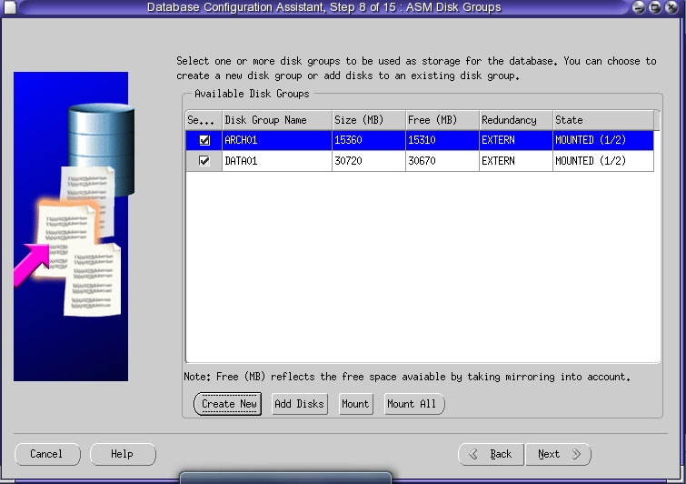

* Specify location for database file:

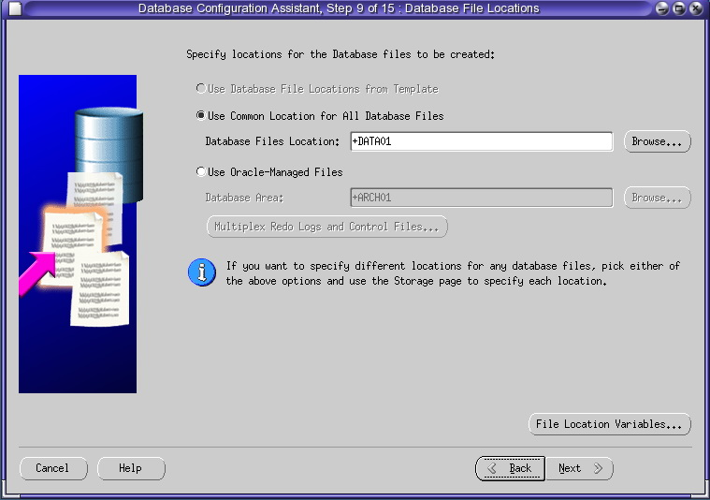

* Specify location for Recovery Area

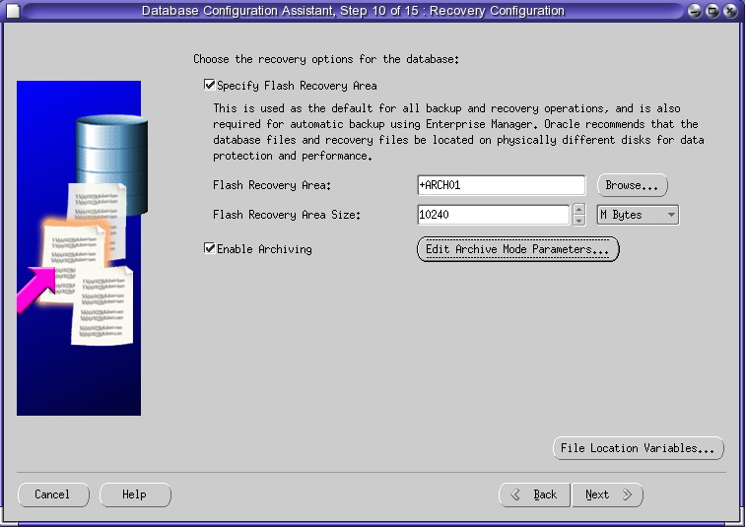

* Select Database Service

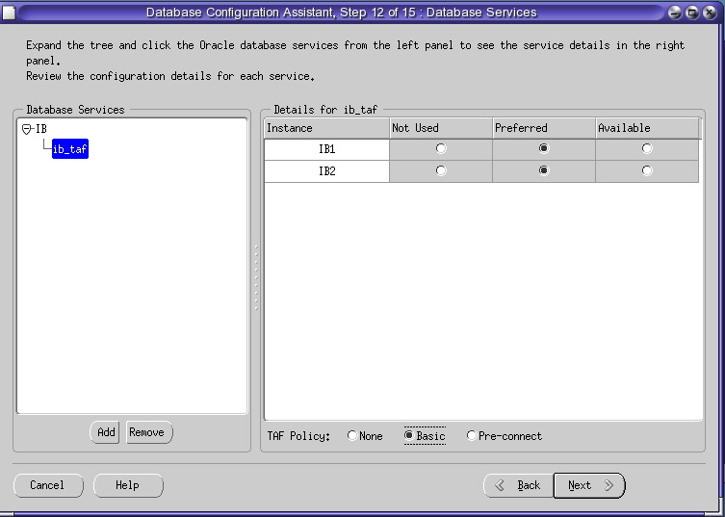

* Set Memory for Oracle Instance

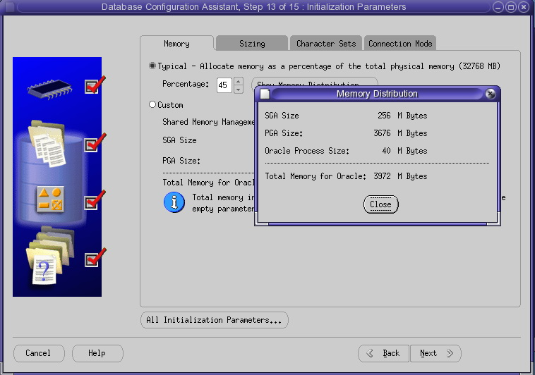

* Set sizing for Database

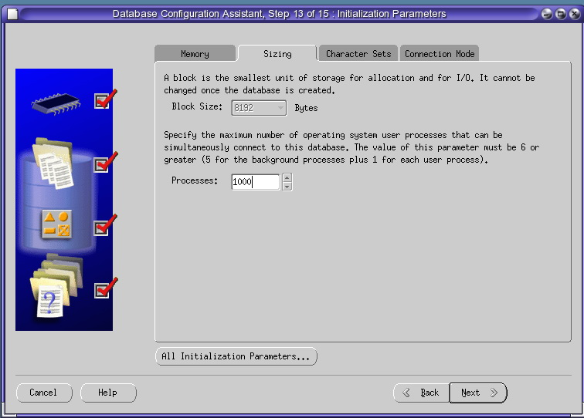

* Select character set for Database

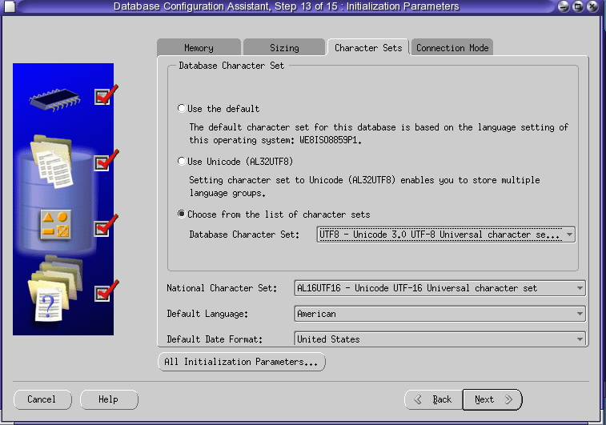

* Select Connection mode

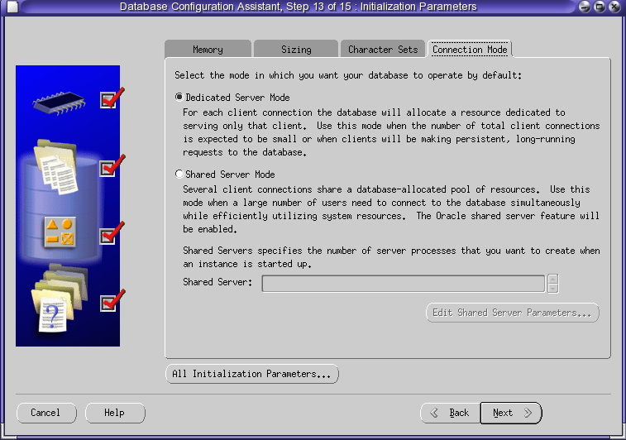

* Set Database storage

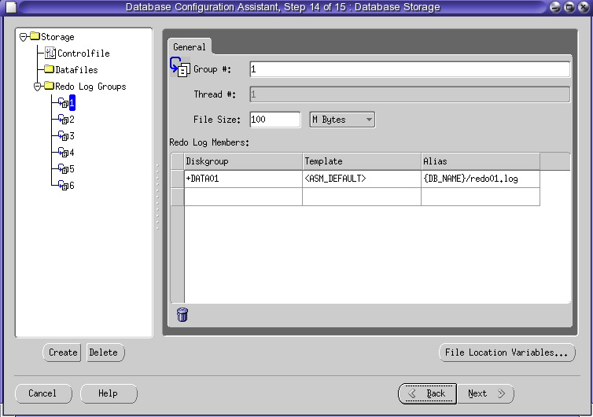

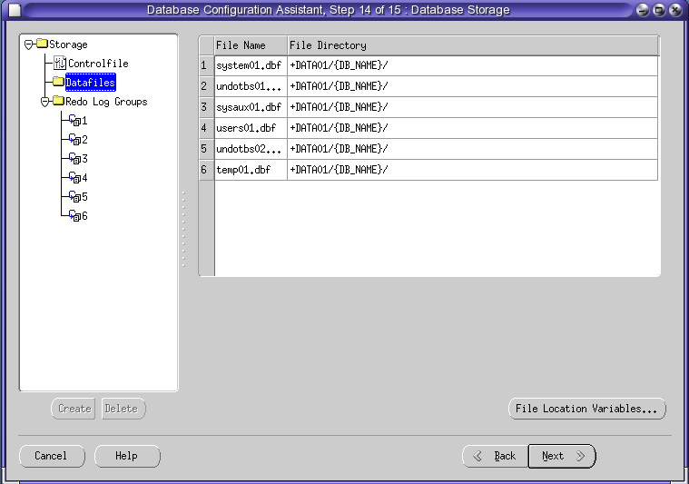

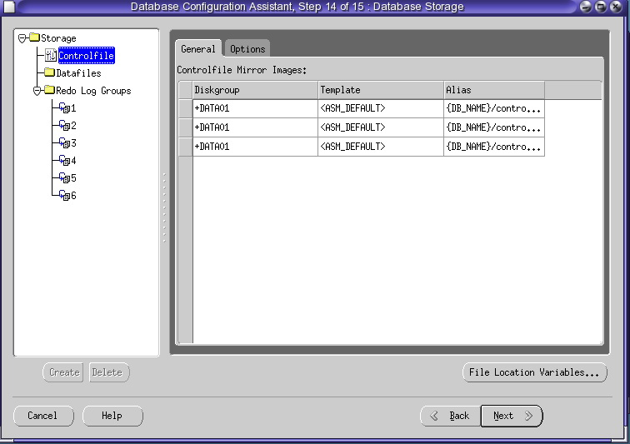

* Creating database

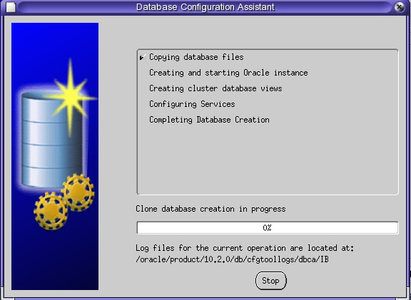

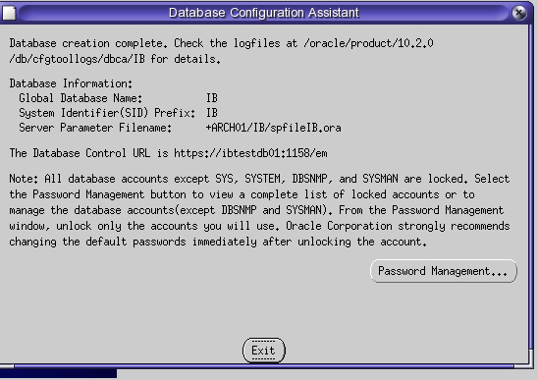

* Upgrade database

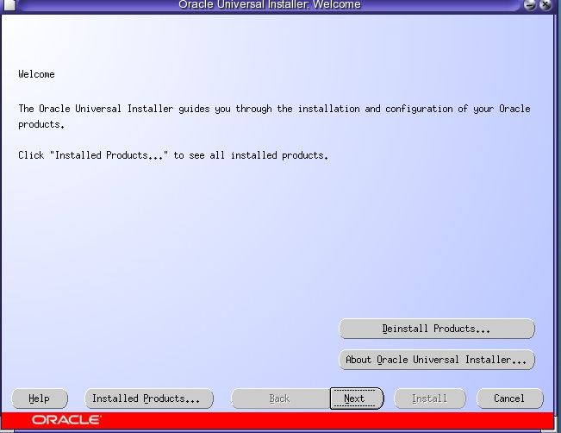

* Specify ORACLE_HOME

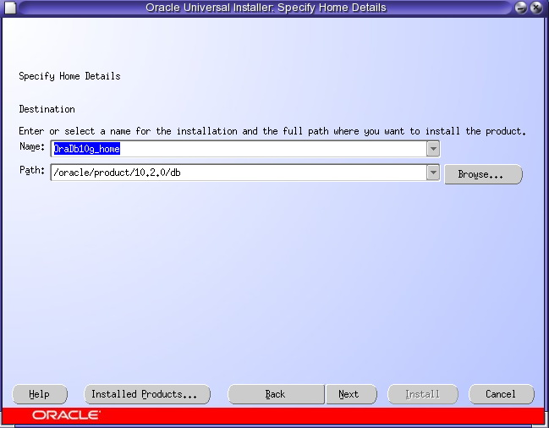

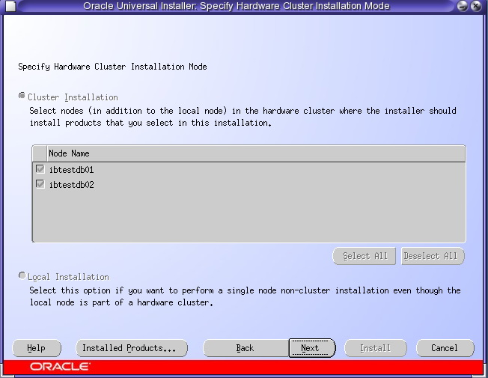

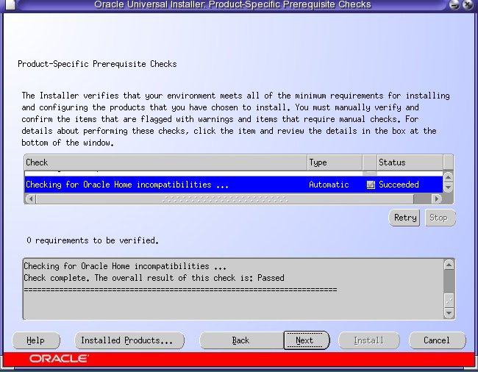

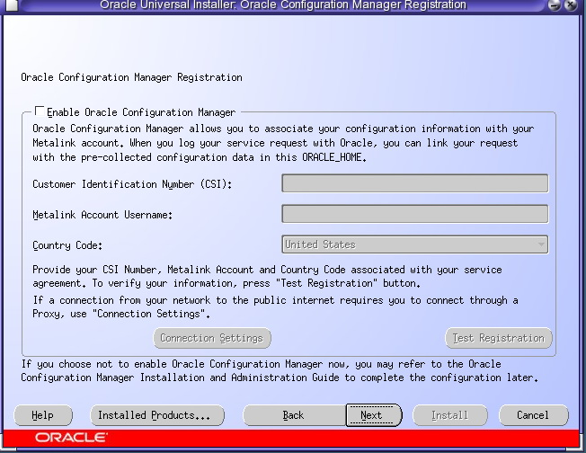

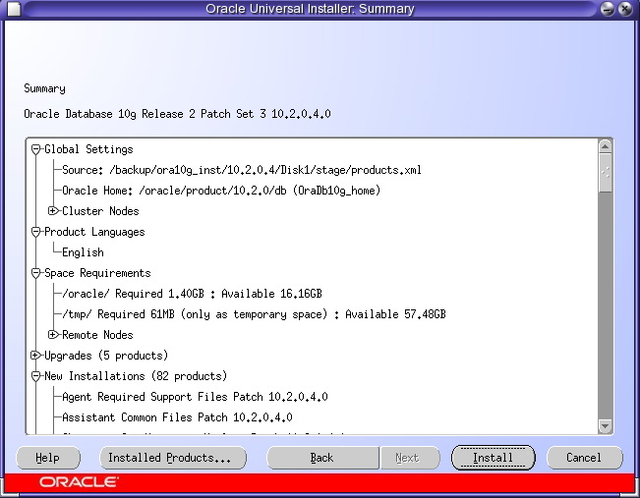

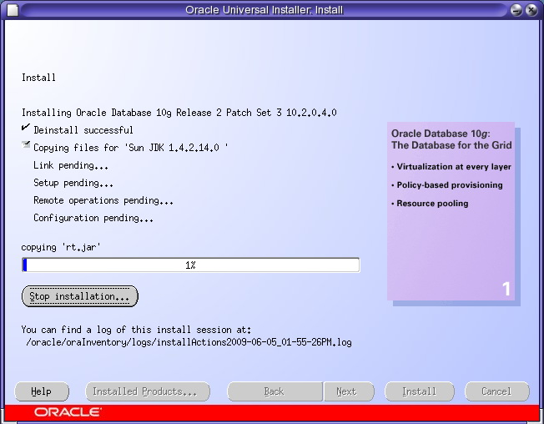

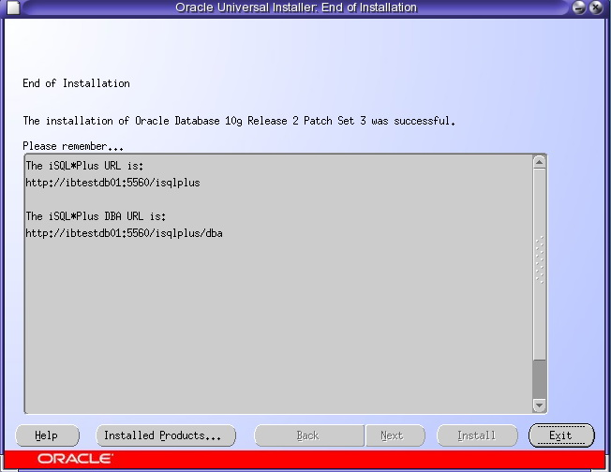

## Vận hành Oracle RAC

### Kiểm tra trạng thái của Oracle RAC bằng lệnh sau

#crs_stat –t

Nếu tất cả các service là ONLINE thì hệ thống hoạt động bình thường.

## Vận hành Oracle RAC

### Kiểm tra hệ thống

Kiểm tra trạng thái của crs

$CRS_HOME/bin/crsctl check crs

Kiểm tra Votedisk

$CRS_HOME/bin/crsctl query css votedisk

Kiểm tra OCR Disk

$CRS_HOME/bin/ocrcheck

Kiểm tra service

#crs_stat –t

### Start/stop Oracle RAC

### Start services

Login as root account, start crs (all components)

$/CRS_HOME/bin/crsctl start crs

Login as oracle account, start services

srvctl start nodeapps -n node_name01

srvctl start nodeapps -n node_name02

srvctl start asm -n node_name01

srvctl start asm -n node_name02

srvctl start database -d db_name

srvctl start instance -d db_name -i instance_name01

srvctl start instance -d db_name -i instance_name02

srvctl start servcie -d db_name

### Stop services

Login as root account, stop crs (all components)

$/CRS_HOME/bin/crsctl stop crs

Login as oracle account, stop services

srvctl stop servcie -d db_name

srvctl stop instacne –d db_name –i instance_name01

srvctl stop instacne –d db_name –i instance_name02

srvctl stop database -d db_name [–o immediate]

srvctl stop asm -n node_name01

srvctl stop asm -n node_name02

srvctl stop nodeapps -n node_name01

srvctl stop nodeapps -n node_name02